**Avoidant Personality Disorder Overview**

**Links**

[Avoidant Personality Disorder: Symptoms & Treatment (clevelandclinic.org)](https://my.clevelandclinic.org/health/diseases/9761-avoidant-personality-disorder)

[Avoidant PD vs Autism (neurodivergentinsights.com)](https://neurodivergentinsights.com/misdiagnosis-monday/avoidant-personality-disorder-vs-autism)

[Avoidant Personality Disorder - StatPearls - NCBI Bookshelf (nih.gov)](https://www.ncbi.nlm.nih.gov/books/NBK559325/#:~:text=Avoidant%20personality%20disorder%20(AVPD)%20is,for%20meaningful%20connections%20with%20others.)

[Avoidant Personality Disorder: 12 Signs, Causes, Coping Tips (mind.help)](https://mind.help/topic/avoidant-personality-disorder/)

[Avoidant Personality Disorder (AVPD) - HelpGuide.org](https://www.helpguide.org/articles/personality-disorders/avoidant-personality-disorder-avpd.htm)

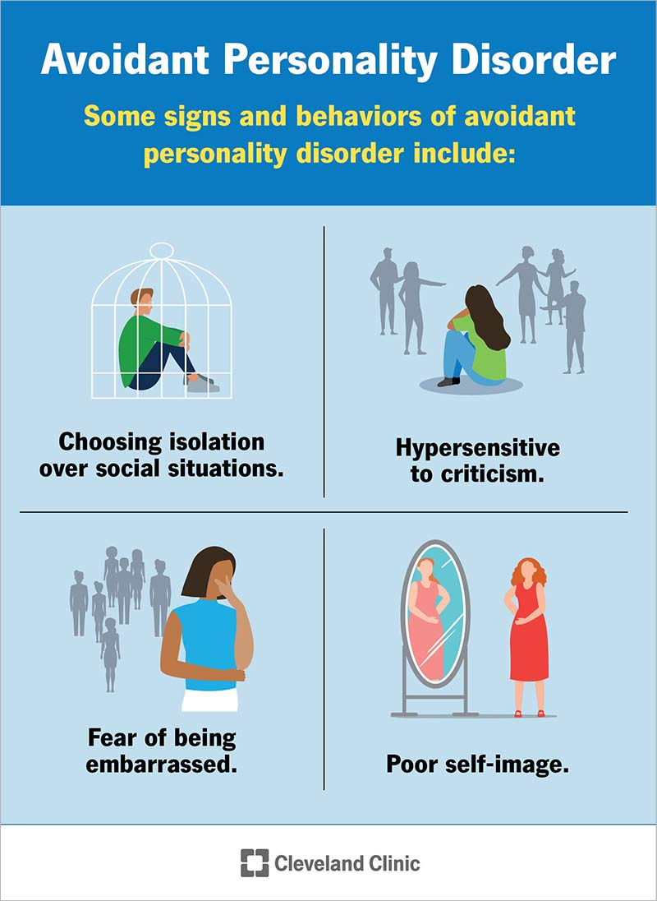

**Two types:**

**Avoidant Conflicted –** avoids others due to fears of criticism, feels confused, unsettled, fear of embarrassment, etc.

Treatment – resolve ambivalence about approaching vs avoiding others

Reduce fears of ruminations regarding rejection and humiliation

**Avoidant Hypersensitive –** intensely wary and suspicious, alternates b/t being panicky/terrified, and thin-skinned/high strung, tends to be brooding and edgy, feels poorly understood

Treatment – reduce social withdrawal, wariness, and suspiciousness, increase ability to self-soothe, self-regulate emotions (more positive then terror)

**Differential Diagnosis**

*Social anxiety is triggered/ Avoidant PD is enduring

*Dependent PD seeks care and nurturance

*Schizotypal/schizoid is ego-syntonic, content with isolation

*Paranoid PD worries about the use of information, hostile motives, rather than avoiding being embarrassed, criticized or rejected

**Overview for diagnosis (must have 4):**

Diagnostic criteria for avoidant personality disorder involve a persistent pattern of at least four of the following behaviors:

* Avoiding job-related activities that involve working with others because they fear others will criticize or reject them.
* Being unwilling to get involved with others unless they’re sure others will like them.
* Being passive or reserved in close relationships because they fear ridicule or humiliation.
* Extreme worry about others criticizing or rejecting them in regular social situations.
* Feeling self-conscious in new social situations because they feel inadequate.
* Assessing themselves as socially unskilled, unappealing or inferior to others.
* Being reluctant to take personal risks or try new activities because they may feel embarrassed.

**Key Reminders**

*Cluster C – involves personality disorders with anxious and fearful characteristics. These include avoidant personality disorder, dependent personality disorder, and obsessive-compulsive personality disorder. Individuals within this cluster tend to experience significant anxiety, fear of abandonment, and an excessive need for control or perfectionism

**Resources**

*Recommend “The Personality Disorders” Treatment Planner – Wiley – 2nd Ed.

*Michael Nash – Personality Disorders training.

_____________________________________________________________________________

**\*Next month Dependent Personality Disorder (Cluster C)**

*Cluster A – Autonomous – (Teacher-Student) Not good with empathy

*Cluster B – Poorly Formed – Increase safety for them to admit

*Cluster C – Inadequate or incompetent – Journaling – attend to the world outside of themselves and facts about the world